Thesis research 1

http://www.nexusjournal.com/Crowe.html
modularity in art
tiling modular games
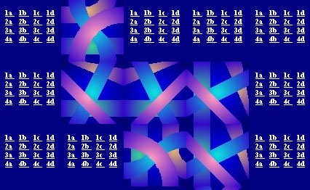
From the layman’s point of view much of architectural construction is modular: bricks, blocks of stone, strips of siding, decorative tiles, etc. It is only by working with modular elements and experimenting with their combinations that we learn - as children do with their Lego blocks - to feel the extent and variety of the visual and conceptual possibilities inherent in even very small sets of structural elements.
Samuel Beckett has alluded to these possibilities in an entertaining scene involving the main character of his comic novel Murphy.

As I’ve mentioned my idea for a thesis to Aneshka, she thought of Escher’s works. I dearly love Escher, and it was a total shock that I haven’t thought once about him in regards to my idea.
http://home.comcast.net/~davemc0/Escher/E92.jpg
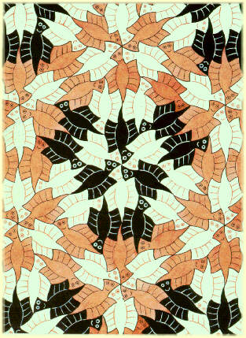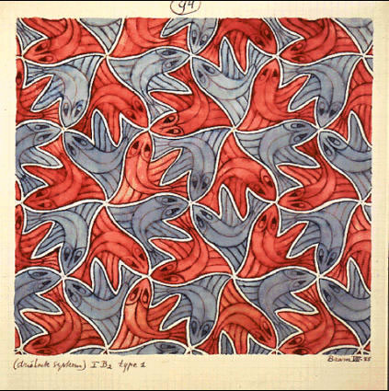

Game Design Workshop
Designing, Prototyping, & Playtesting Games
Author: T. Fullerton, C. Swain, S. Hoffman
http://www.wired.com/news/games/0,2101,61682-2,00.html?tw=wn_story_page_next1

