Table of Contents
Table of Contents 1
Illustrations 4
ABSTRACT 5
INTRODUCTION 6
CURRENT MARKET SITUATION 7
THREE GAME MODULES 9
GAME DESIGN 10
Game as a System 10
Core Mechanic 12
The development of the idea 14
Initial Concepts 14
Paper Prototype 15
Final Idea 17
RESEARCH OF THE TIME PERIOD 17
RULES OF ADVENTURERS’ CLUB 18
Starting the game 18
Game Play 19
End Of the Game 19
Game Overview 19
City 20
World Map 22
Game Engine: 23
Economic System 24
World Economy 24
Price calculations and display 25
Transportation System 26
Travel speed algorithm 27
Travel Price 29
Social System 29
INFORMANT 30
QUEST PROVIDERs/RECEIVERs 30
KNOWLEDGE PROVIDER 32
GATEKEEPER 32
Lost Cities generation 33
Some mistakes 34
DEVELOPMENT 36
Development Environment 36
Programming Macromedia Director MX. 37
Composite objects 38
Dynamic sprites 38
OOP specifics 39
World generation tools 39
EVALUATION 40
CONCLUSION 40
Appendix A 41
Knowledge Distribution 41
Atlantis 41
Machu Picchu 42
The Sun City – (African jungles) 43
Island of Dead Ships 44
Agharta 45
Appendix B 46
Gatekeepers’ Messages: 46
Captain Nemo 46
Professor Lidenbrock 46
Lord Glenarvan 46
Dr. Samuel Ferguson 46
Robur the Conqueror 46
Appendix C: Game Design and Development 47
Works Cited 50
LUDOGRAPHY 52
Multi-platform games 52
Digital Games 53
Board/Card Games 54
BIBLIOGRAPHY 55
GAME DESIGN & HISTORY 55
GAMING 56
VICTORIAN ERA: HISTORY & DESIGN 56
PERSONAL INTERVIEWS 58

Illustrations
Figure 1. Grand Theft Auto III 8
Figure 2. Max Payne 8
Figure 3. Cubis 8
Figure 4. Zuma 8
Figure 5. Adventurers' Club: Paper prototype 16
Figure 6 City - Main Menu 20
Figure 7 City Store 21
Figure 8 World Map 22
Figure 9 NPC - Informant 30
Figure 10 NPC – Captain Nemo 32
Figure 11 Destination Screen 36
Figure 25. Objects Interaction Diagram - game start 46
Figure 26. Objects Interaction Diagram - player enters the city 46
Figure 27. Class Diagram [this is the old iteration for the final I will provide a new one] 47
Figure 28. Database Design [this is the old iteration, for the final I will provide the new one] 48

MFADT Thesis
Instructors:
Dave Kanter and Melissa Rachleff
April 14, 2005
THESIS: ADVENTURERS’ CLUB
Single player game about traveling, collecting and exploring in the late 19th century

ABSTRACT
Adventurers’ Club is a single player computer game about traveling, collecting, and exploring in the late Victorian Era. The game content is filled with the historical references of the time, as well as fictional historical events and characters based on Jules Verne’s novels. Players visit different cities, buy special collections, get companions on their journey, and discover the Lost Cities. The game runs in a weekly cycle, where each week the new game world is generated and players can download it from the web. At the end of each game cycle the player is able to post his final score and adventurer’s rating on to the game’s website. Adventurers’ Club is developed using Macromedia Director, PHP, and SQL. To provide for the ability to fine tune the balance of the game, a set of “world generation” tools is provided. Those tools allow special variables to be tweaked without changing the code of the game.

INTRODUCTION
My interest in games goes way back to my childhood. I was fascinated with chess from the time I was 5 years old. Then came other board/table games and, of course, arcade machines. Being born and raised in St. Petersburg, Russia, during my childhood I didn’t get the chance to experience the gaming industry’s “golden years”. In Russia the industry wasn’t as developed as in the US. I didn’t have an Atari, but I had a “Telesport” – a Russian very primitive game console, and I loved every minute of playing that thing. My interest in games grew with time, and I got very much involved in computer games. I enjoy all sorts of gaming genre; “adventure games”, though, being my favorite. I’m 27, I still want to play, however I cannot indulge myself in playing games at the same rate that I used to. Some friends of mine are in a similar situation; they grew up and now have to worry about “real grown-up” things such as a real job and a family. The major force that is driving me to create a game targeted to the “grown-up” players is a strong wish to have such a game created for myself and for my friends.
In the past 30 years computer games have grown to be a huge part of the entertainment industry. However, the first generation of “gamers” recently seems to be falling out of the game world. The generation in question covers people that are in their late 20s - early 30s, or whose childhood or early teens came upon the “Golden Age of Gaming”. One of the reasons for the decline in their game play is the simple problem of growing up, getting a real job, having a family and not having enough time to play. This problem is occurring across the gaming industries and not only with the computer games.
For gamers that don’t have 7 hours a day to dedicate to the continuous play, but who really love games there needs to be created a gaming environment that is adjustable to the player’s life style. The problem of creating such an environment can be tackled by creating a gaming experience that consists of different self-sufficient modules, where each module is designed for a certain game-playing timeslot of the player, and at the same time, in the game design sense, all modules fit together to create a metagame.

CURRENT MARKET SITUATION
In US there is a big community of people over the age of 25 who grew up playing games and don’t really want to let go of play any time soon. Those grown-up gamers don’t often have the same freedom to play games that they had in their high school and college years. The gaming industry recognizes that large population of grown-up gamers is departing from the gaming world, and I’ve noted some trends that are taking place in order to resolve this problem.
The first trend pertains more to non-digital games that are also losing grown-up players. The card game Magic The Gathering at one point started losing a large population of gamers. Richard Garfield, the creator of Magic, in his Magic Design: A Decade Later essay stresses that the game was losing players, who loved the game but simply didn’t have time to play it anymore (Fullerton, Swain and Hoffman 195). For R. Garfield the answer to the quickly growing problem was - Magic Online. Some studies of the player’s demographics have shown that a large percentage of people who are playing the online version of Magic were old players of the “real” game. Once they were given an opportunity to play from home and during the time that they wanted, probably once kids went to bed, they were back in the game.
The second trend in the fight for the grown-up gamers is the change of themes of the games and the drive for the ultra-realistic environments. The first console game targeted specifically to the “grown-up” audience was Grand Theft Auto III. The game character is a thug, whose main activity is to steal cars and beat people up.
“As many gamers already know, GTA3 sold like wildfire and was applauded for many reasons. Everything about GTA3 was excellent and new (and yet based on the same framework that the first games were based upon): The open-ended game design, the phenomenal level of detail, its huge worlds, the closer, third-person perspective camera, the sophisticated AI, the sexy and sometimes dirty cutscenes, and moreover, the way in which the game aimed itself at a sophisticated gamer who wanted more than just to save a princess from a cranky dragon”(Perry).
Games such as Max Payne were also targeted mostly towards “sophisticated gamer”. The visual realism, as well as the freedom of actions a player can take, have a magnetic quality; making it hard for the players to stop playing.
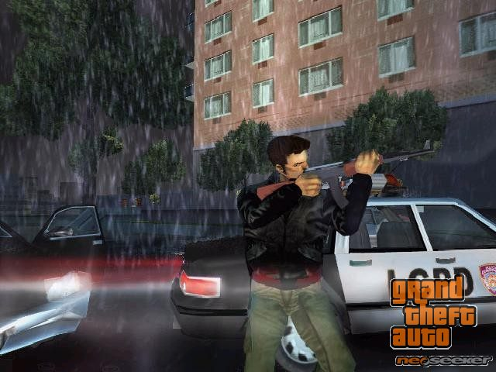  Figure 1. Grand Theft Auto III | 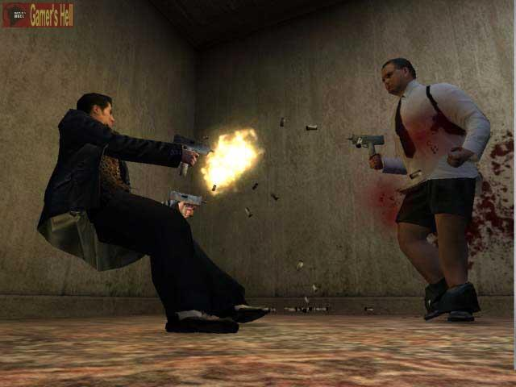  Figure 2. Max Payne

Today’s game market pays high level of attention to the “non-commitment games”. This makes the online internet games to be the third trend on my list. Games of this category usually are hosted by large game portals; such as www.popcap.com and www.yahoo.com. Players don’t even have to download those games to play. The genre covered is mostly action arcade or puzzle games.
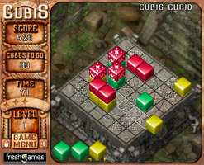  Figure 3. Cubis | 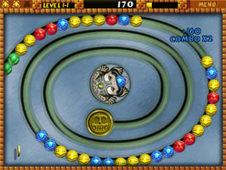  Figure 4. Zuma

It is interesting that the players of “non-commitment” games have a very different demography from the rest of the gaming community. Compared to other sections of the industry a much larger population of women play “non-commitment games”. An interesting study of online gamers’ demographics was done by America Online (AOL) in January of 2004. America Online (AOL) has found that females over 40 years old spend the most time per week playing online games at 9.1 hours, which accounts for 41 percent of their connection time (Greenspan). The reason I’m categorizing online puzzle/arcade games into “non-commitment games” is that generally speaking those games don’t require the same amount of investments as action/adventure games, or as MMORPGs. Not only the price differs tremendously, most of “non-commitment games” can be played for free, but also the time a gamer needs to spend with the online puzzle/arcade game in order to get the best immersion into the game is much smaller than that with the action/adventure games, or with MMORPGs.
A very strong trend in the industry’s wish to conquer back the grown up gamers can be seen in the tremendous growth of the mobile gaming. People play games using their cell phones, SMS messaging, and PDAs. Nokia’s N-Gage and Tapwave Zodiac are the strongest platforms that are turning a phone or a PDA into a full functioning gaming platform. Tapwave Zodiac is a Palm-based gaming platform, and it is positioning itself as “a PDA for the Grown-Up Gamer”(Tapwave Zodiac Advertisement). The position of the large gaming corporations is that older people don’t have time to play, and that is why they should be provided with the technology to play on the go.

THREE GAME MODULES
All of the earlier discussed trends expend on the idea that grown-up players don’t have time to play. And the gaming industry creates a variety of solutions to the problem based on that assumption. My hypothesis is that grown up player’s game time is not only decreasing, but it is actually very fragmented. For those players every second of their game time is valuable. They can spare for gameplay maybe half an hour in the morning, 40 minutes during the morning commute, 30 minutes during lunch, 30 minutes when the boss is not watching, 40 minutes during the evening commute, and maybe 2 hours at night. Currently games do not account for the fragmented play time that a player has. Most of the games rely on spending long hours of continuous play time in order to get the full immersion into the game. I would like to propose a creation of a game that can solve that problem of fragmented playtime for grown up gamers. The game environment for such a game should include several “game modules” that differ in game play, but together create a metagame experience for the player.
The game will be playable over three different gaming platforms: desktop, PDA, and Internet. Each of those platforms adheres to a certain “time slot” that a person has available for play during the day. Desktop, being a stationary system, will be used for game play at home, PDA is all about playing on the go, and Internet, with its’ great availability, can be accessed throughout the day from different devices. I’m planning for all the platforms to be interconnected through the central database, so that all devices constantly know the player’s status in the game.

GAME DESIGN
The discussion of game design as a discipline in its own merit is a new one. For ages games were examined through the filters of other disciplines. Fields of philosophy, psychology, physiology, mathematics, cultural studies all have discussed games in their own contexts and terms. It seems that it is the boom in the digital gaming that sprang up a want and a need for theoretical plus instructional framework around the process of creating games.

Game as a System
Important concept in the development of the game is looking at games in terms of systems. Following Salen and Zimmerman’s definition “a system is a set of parts that interrelate to form a complex whole”, a game can be framed as a mathematical, social or representational system. In Rules of Play Salen and Zimmerman draw their ideas on systems from Stephen W.Littlejohn’s textbook Theories of Human Communication, where he describes the elements of the system. Those being: objects, attributes, internal relationships and environment (Salen and Zimmerman 50 - 51).
The main “object” of the Adventurers’ Club is the player. The player associates himself with the virtual protagonist of the game – the adventurer of the 1875 whose goal is competing with other adventurers for game points. Obviously all of the opponents of the player are also important “objects” of the game system. The cities, the collectable items and even the NPCs are all part of the system, and are also considered to be the “objects” of the game.
The second element of the system is attributes – “the qualities or properties of the system and its objects” (Salen and Zimmerman 51). In the analysis of the Adventurers’ Club attributes would be the rules of traveling, collecting, discovering and trading in the game world. Attributes will be the rules of moving from one city to another, rules of trading collectable items with other players, rules of collectable sets having specific prices based on the “fullness” of that set.
The third element of the system is the internal relationships that exist among objects. Strategic relationships in the game are determined by the location of the player at any given moment. All actions the player does, such as buying a collectable item, agreeing to take a “special” NPC as a party member, deciding to go to a specific city, and the like, constitute the internal relationships of the game.
The environment of the game world provides the context for the formal elements of the game. The narrative of the Adventurers’ Club is driven by the actions that players take during the game-play.
Describing a game in terms of a system helps to see how the game system adds up to a larger experience of play. And it leads to understanding games as “emergent systems”. Emergence in a game is something very crucial to the successful game play. In the end game has to be fun, and player has to come back to it time after time. The concept of emergent system is greatly summed up by Jeremy Campbell in his Grammatical Man “A modest number of rules applied again and again to a limited collection of objects leads to variety, novelty, and surprise. One can describe all the rules, but not necessarily all the products of the rules…”(Salen and Zimmerman 158). And that is precisely what one has to strive for when developing a game. A system with definite rules, but a variety of possibilities for game-play that comes out of those rules. The mastering of the rules shouldn’t stop the player from playing, but make it ever more interesting to play.
When working on the game design of the Adventurers’ Club special attention was paid to the concept of games as emergent systems. It was important for me to come up with a game, where by learning the rules of the game the player wouldn’t loose interest in game play. Hence, the emphasis on the variety of meaningful choices that a player has through out the game. Should he choose the role of a “fast traveler”, “discoverer”, or a “collector”? Also the relationships between certain objects in the game will regenerate anew in every game session, the player will have to figure some parts of the game each time he plays.

Core Mechanic
The building block of a successful game is the notion of the Core Mechanic. As defined in Salen and Zimmerman’s Rules of Play “a core mechanic is the essential play activity players perform again and again in a game”(Salen and Zimmerman 316) . One or several activities that a player is involved in during a game create the actual gaming experience for that player. There is a basic level of core mechanic in a game, and a more conceptualized level. In digital games describing core mechanic as hitting the keyboard key LEFT, RIGHT, UP and DOWN (as in TETRIS) would constitute the basic level of core mechanic. However, in the initial stage of game design it is useful to go that far into analysis of core mechanic of the game.
When working on the Adventurers’ Club, I found it useful to start with that “basic” core mechanic and then, rather quickly, to move on to more of a conceptual form of a second level of core mechanic. At that level, questions such “what does the avatar in the game does?” come to mind, rather than “which button does the player hit?”. The second level core mechanic of the Adventurer’s Club can be described as follows:
The adventurer chooses mode of transportation, buys a ticket and travels from one city to another. In the city the adventurer can buy and sell the collectable items, get a quest, or learn some news. On the handheld the adventurer also learns where rare collectables are located. And on the web the adventurer is able to trade the collectables with other “real life” adventurers.
For any game to be successful there needs to be tension involved between different aspects of what the player can do. There needs to be two axis of conflict (Fortugno). Player would want to follow one axis, but then the second axis would also provide some kind of benefit. For example, in Civilisation series, a player is often faced with the decision of using his resources for one thing and sacrificing something else in the process (i.e.: building a “wonder” instead of an army).
To understand what is fun in the game when the core mechanic is traveling from one city to another, I researched a great deal of games. One in particular stands out as highly relevant to my design process. It is a board game “Ticket To Ride” by Alan R. Moon. It is set in 1900 and plays off Jules Vern’s Around The World in 80 days. The historical content in this game comes into play only in so far as illustration on the box. “Ticket to Ride is a cross-country train adventure where players collect cards of various types of train cars that enable them to claim railway routes connecting cities throughout North America”(Moon).
I found this game when I was well into the development of my thesis project. Once I learned that the game is supposed to be a play of Around The World in 80 days and knowing Alan R. Moon as a master of game design, at first I got disillusioned in the making of my game. I played Ticket to Ride a great number of times; I absolutely fell in love with the simplicity of game play. And I also understood that even though Adventurers’ Club is also based around the idea of Jules Vern’s Around The World in 80 days, the game play of Adventurers’ Club is much different from the Ticket to Ride. At that point I was able to rationalize better and I started learning from the incredibly simple and at the same time addictive core mechanic of the Ticket to Ride. Players try to claim railway routes by collecting cards, and the tension comes in when players are faced with the decision which route to claim, and how long of a travel route to create.
Another game, core mechanic of which I found to be influencing some of my thinking in regards to core mechanic of the Adventurer’s Club is Oasis. Oasis is a fast-paced strategy game, designed to be played in minutes instead of hours (Mind Control Video Games). The game world of Oasis is dynamically generated each time one plays the game. However, there are some constants in that world that help the game to be a strategy game rather than just a guessing game. The player has to find an oasis and an obelisk, while finding cities and building the infrastructure between them. This has to be done in a set number of turns, before the barbarians will start their attack. What is appealing in this game is the dilemma that the player is faced against, should he try to find the obelisk and risk the underdevelopment of his cities, or should he play more carefully and get less points?

The development of the idea

Initial Concepts
The inventing of the game started after the main concept – having different platforms covering different time segments – was finalized. Before the development of the game design, I formulated the following requirements for the game:
1. The game should have different activities suitable for each of the platforms. Though the desktop platform could support any type of activity, the handheld and the web had more specialized capabilities.
2. The game should have a clearly defined and reachable in a reasonable time ending. This also implies that the game should have high replay value.
3. The success in the game should not depend on the time spent online. This is a common trait of most modern multiplayer games, and it is absolutely unacceptable in the game targeted on the grown up audience with highly fragmented time.
Keeping these requirements in mind, I’ve started inventing the game.
The first concept was dealing with adventures in a sci-fi setting. The idea was to create a game about “post-informational” society, where the protagonist will try to find a solution to the consequences of “informational explosion”. However, though the idea seemed quite promising, after some considerations I had to give it up. The reason for this was the fact that the game was driven mostly by the plot, and depended heavily on the narrative, which significantly reduced the replayability.
Then a concept of following the steps of Jules Verne’s characters appeared, and became a base for the “Adventurers’ Club”. Initial idea was that the players just race against each other, and the first draft included such elements as arcade mini-games and trading of information on the web (telling each other details about visited cities for some fee). The idea of mini-games was sacked pretty soon, due to the fact that it would be next to impossible to create arcade sequences random and diverse enough to maintain replayability, and well-designed to be interesting at the same time. The information trading also did not survived, because of the difficulty to keep players’ game time in sync.
The game clearly required some other dimension besides racing around the world to be fun and enjoyable – otherwise all players’ activities were limited to selecting next destination from the list of available cities.
Then the idea of collectable items came up, and the game began to take shape. Player had several choices now that he could make during the game play, as well as the choice of which way to end the game. The game design is still evolving, and just recently after the play-testing of the paper prototype the idea of special “party members” also came to life. Now, I think that I have a general structure of the game in place, and further play-testing is needed to balance the game better.

Paper Prototype
To truly work on the game design one has to be able to start play-testing the game at the earliest possible moment. With digital games this can be a little bit problematic, for the creation of the software prototype can often take up a really long time. Thus, it is important to create a “paper prototype” of the game. Game designer can even create several game prototypes that correspond to different parts of the game.
“Physically prototyping allows you to build a structure for the game, think through how the various elements interact, and formulate a systemic approach to how the game will function” (Fullerton, Swain and Hoffman 163).
In the development process of the Adventurers’ Club I started with a strong impulse to start building a fully functioning software prototype. I stopped when I saw myself programming the game before actually designing the game play and that same evening I made a paper prototype of the part of the game. It’s a prototype of a “desktop” module.
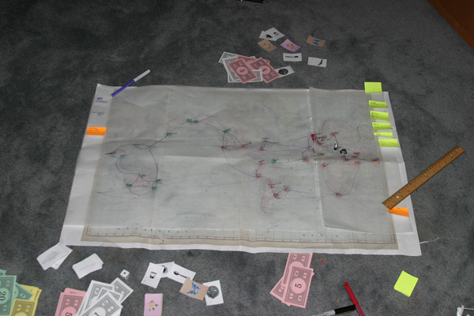
Figure 5. Adventurers' Club: Paper prototype
For the first iteration of the paper prototype I’ve simplified the game-play, leaving just the most important objects and actions of the game in place. The very first play-test provided a big insight into the game play of Adventurer’s Club. First of all, on the very basic level, it was fun to go from one city to another and try to collect different items. However, what was not fun is being stuck in a city with no money and unable to go anywhere else. The following is the list of major things learned from that session:
- better balance is needed between the prices of different modes of transportation, as well as the time that it takes to travel by steamer vs. the railway.
- each city needs to have a travel way to at least two (better three) other cities.
- The initial amount of money that a player gets should be enough for the player to be able to start his travel right away, as well as experience the process of collecting. Yet, the amount shouldn’t allow the player to travel around the world without ever collecting, selling, or trading game objects.
The paper prototype became the integral part of the game design of the Adventurer’s Club, and it is constantly being used and updated.

Final Idea
When the production process was well on the way, I realized that the scope of the game was too big to handle in the amount of time allocated for the thesis project. One of the most challenging decisions that I had to make was to cut the game down. Here I present a single player one platform version of the game. This prototype demonstrates the core game mechanic of the Adventurers’ Club, yet it is still flexible enough to be further developed to include the multi-platformed component of the gameplay.

RESEARCH OF THE TIME PERIOD
During the development process a preliminary study of the period was conducted. However, it is important to recognize this as not being the historical dissertation, but a game that is set in a historical period. During future development of the project a knowledgeable historian will be hired to attest for the historical nuances of the game.
In short, the second half of the 19th century was an exciting time. The map of the world still had some white spots, but at the same time the known part of the world was becoming more and more easily accessible. Getting from London to India was just a matter of purchasing a ticket to the right ship. Here and there were happening important developments in the transportation systems. In 1853 first railway was built in India, and in 1869 transcontinental Rail Service started in the United States. And the completion of Suez channel brought oriental countries almost 5000 miles closer to Europe.
The game that takes place in the late 19th century should not be based on the historical facts alone. Most gamers know the time period mostly not from the history lessons or serious scientific volumes, but from the literature. Fortunately, the literature of the late 19th century goes very well with the selected game genre. Adventure novels are very popular at that time. Of course, one of the most famous adventure writers of that time was Jules Verne. He was one of the people who created the image of the 19th century adventurer. His works published in the 1860s-1880s:
1863: "Five Weeks in a Balloon"
1864: "Journey to the Centre of the Earth"
1870: "20,000 Leagues Under the Sea"
1875: "The Mysterious Island"
1886: "Robur the Conquerer"
The visual look and feel of the game corresponds to the “High Victorian” style of the time period. Photographs from the time period in Adventurers’ Club serve as illustrations to each of the many places that a player can visit. A lot of photographers of the period made it their priority to travel and photograph the world. Photography was a very important part of the periods’ aesthetics, and not to include it in the game’s world would be a mistake. The characters that the player meets are all illustrations from the late 19th century, or imitations of the style of the times. Many character designs in the game are based on Racinet’s work. In 1888 Racinet published full color pictorial history of the western costume; this work was technologically and esthetically very important to the period.

RULES OF ADVENTURERS’ CLUB
Adventurers’ Club is a single player computer game about traveling, collecting, and exploring in the late Victorian Era. The game runs in a weekly cycle, where each week the new game world is generated and players can download it from the web. At the end of each game cycle the player is able to post his final score and adventurers’ rating on to the game’s website.

Starting the game
Before starting the game each player needs to set up the account. It is done at the Adventurers’ Club Web headquarters. Once the player got a login name, and downloaded the game and the current world he/she is ready to play.

Game Play
Players’ main goal is to get the maximum number of points during his game play. There are several ways in which a player can get points.
- Visiting a city.
- Resolving a quest.
- Finding a lost city.
The player starts out with a certain amount of money. The money in the game is being spent on travel tickets and collectable items. The money can be gotten by successful sales of collectable items or full sets, and by completion of certain quests. The game play consists of investigating the different city areas, traveling from city to city, finding the collectable items, inviting different NPCs to become player’s companions during the journey, finding information about the lost cities, and visiting the lost cities.

End Of the Game
The player looses the game if he runs out of money, and cannot sell any of his items to gain more money. At this point the “end game” screen is displayed, and the player is given an adventurers’ rank based on the points that he has accumulated during the game. The player has an opportunity to publish his score and rank online in the Adventurers’ Club Web headquarters.
If the player plays successfully for the entire week, he has the better chance of getting the highest score and the highest rank. At the end of the week he is prompted with the opportunity to publish his score and rank online.

Game Overview
There are two stages in the game where a player can perform different actions: the city and the world map.

City
In the city the player is able to check out the store, the news stand and the city center. In some cities the player can also find the Adventurers’ Club Headquarters. Each of those city areas has a specific function in the game. | 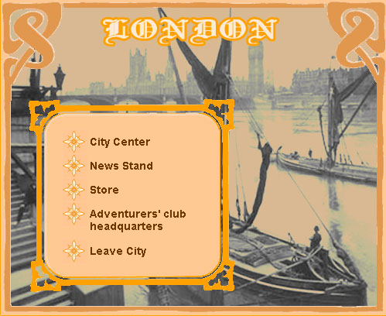  Figure 6 City - Main Menu

Store
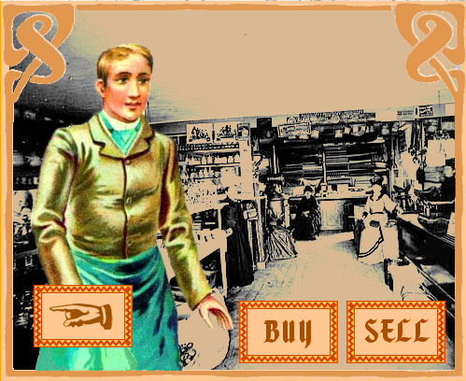  Figure 7 City Store | In the store the player is able to buy and sell items. Each item belongs to a “set”. Items are the things that were highly popular to collect during the late Victorian period. When a player sells an entire set the price he gets is much larger than if he would be selling the items separately. Another special ability that “sets” have is that having the right “set” is the only way for the player to get a party member.  Party members give special abilities to the
player for the limited period of time. Once the player buys the item, it will show up in his inventory.

News Stand
News stand is the place where a player can learn the dynamic news that are happening in the world. The player can find out news about the major economic boom or depression in a particular city. The global events that influence the economy or modes of transportation systems are all timed. For example, “boom” in New York for exotic products would last for 14 days.

City Center
City center is the place where the player can meet the “locals”, - NPCs. There are different kinds of NPCs player meets in the city center. Some provide static information in regards to some of the cities’ economic policies, some are quest givers/receivers, and some provide the player with little bits and pieces of the information about the lost cities.

Adventurers’ Club Headquarters
Adventurers’ Club Headquarters is located in a small quantity of cities. Some NPC’s have information in regards the location of ACH, but some the player will have to find on his own.
In the club the player is able to get the party members in exchange for the set of items that this party member wants. For example, to get a colonel the player would have to have a collection of swords in his possession. Once the player agrees to take the party member, the collection set, that was the price for that party member, disappears from the players’ inventory. Player can have only up to 3 party members at the same time. Each party member has a specific time that he/she can spend with the player. Party members have special abilities that help the player along the way. For example a bodyguard will save the player from loosing money if the train during the travel was robbed. A colonel will open up certain travel routes for the player that are locked off otherwise.

World Map
When leaving the city the player is faced with the world map. There is also a destination window that appears on the right of the game screen. The player should select the city that he wants to visit, and the mode of transportation that he wishes to use. The transportation modes differ in price, speed and deviation factors. | 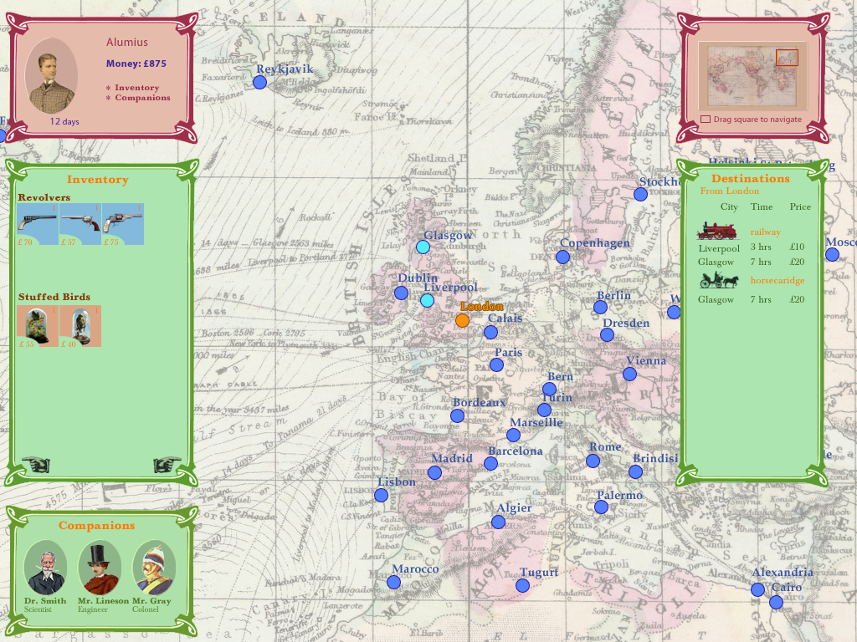  Figure 8 World Map
What is meant here by the deviation factors is the probability of losing/gaining time and money during the travel. For example the European railroad is fairly safe. It can maybe slowdown sometimes, but nothing major. In America, though, the trains often undergo a robbery. A player will loose time, and, if there is no bodyguard in his party, money. Another example would be a difference between steamers and yachts. Steamers are more stable, and on average have a higher speed. Yachts on the other hand, if the wind is right, can go faster than any steamer would.
So by selecting the destination city and purchasing a ticket the player will move to the selected city. If anything of interest would occur along the way, the player will get a message explaining what happened.

Lost Cities
For each game cycle six lost cities are selected out of the pool of twenty. The knowledge about a lost city is distributed more or less close to it. Each piece of knowledge is equivalent to a certain percentage of known facts about that city. Some facts include the legend/myth, some the name of the adventurer who might know something on the subject. Once the percentage of knowledge has reached the mark of 80% the player gets a letter from a character that is willing to take him to that lost city. All the information that the player discovers about the lost cities is recorded in the “lost cities screen”. When visiting a lost city a player is able to get a unique item for his collection.

Quests
Some NPCs in the city centers can offer a player to take on a quest. Quests are time-based (or better said turn-based). The variations of the quests are as follows:
- Deliver a letter or a parcel
- Find and buy a certain collectable object, and then bring it to a particular city.
If the player agrees to take on a quest, the quest appears in the player’s quest screen. Quests have different rewards. Some are money based rewards, some will open a new transportation mode, some will reward a player with a rare item. If a player takes on a quest but fails to complete it, he will loose money.

Game Engine:
The game world consists of the economic, transportation, and social systems. The following descriptions are the overviews of how those systems were created, as well as how they function in order to create a believable world.

Economic System

World Economy
Early play-testing sessions showed that the collection of items in the Adventurers’ Club plays a vital role for the game. The economy of the world was designed in a simple way of cities having set prices for buying and selling items based on the rarity of those items. However, it was understood very soon that such treatment of the economy jeopardizes the game-play. People would not really have a tendency to “sell” items, all they would be doing is buying as much as possible. To make the game-play more interesting a more intricate world economy was created.
Now, the pricing of items in the cities (both selling and buying) is determined by the pricing policies. The pricing policies consist of two parts: policy and boom factor.
The policy determines general pricing strategy of a given city. It is being generated once for each game cycle, and does not change during the game. Some cities turn out to be very “cheap”, and some - very “expensive”. Some cities might want to sell the items from its region at a much lower price than the items from other regions.
The boom factor reflects price fluctuations based on some world events (for example – “Collecting is on rise in Europe” – all prices in Europe increase; or “America is flooded with forgeries” – all prices in America drop). The boom factor for any city can change during a game.
The policy consists of 5 elements. Each of the elements represents a pricing factor for a specific type of items. Here is the list of the policy elements:
- Pricing factor for the items that the store sells itself.
That factor is applied when the player wants to sell an item that this particular store sells. The sell price for that item will be calculated using this factor. For the algorithm of price calculation this factor is called “OWN_BUY”.
- Pricing factor for the items the set of which belongs to the region of the city.
This is also for the items that the player is trying to sell to a store. Each collection set knows to which region of the world it belongs. As a result each item “knows” where a player wants to sell it: in its region or outside of its region. This, in turn, influences the selling price. For the algorithm of price calculation this factor is called “REG_BUY”.
- Pricing factor for the items the set of which belongs to other regions.
The explanation of this factor is identical to the explanation of the 2nd factor. For the algorithm of price calculation this factor is called “WORLD_BUY”.
- Pricing factor for the items that are up for sale in the store, the set of which belongs to the region of the city. This price factor affects only the items that the player can buy in a given store. For the algorithm of price calculation this factor is called “REG_SELL”.
- Pricing factor for the items that the player can buy in the store, the set of which belongs to other regions. For the algorithm of price calculation this factor is called “WORLD_SELL”.
Similar to 4th factor the items here are available for purchase in the store.

The process of distribution of prices in the world consists of two steps. First, using the PHP script each city get its cheap/expensive index. Then, inside the director application there is a script that applies the pricing policy (described earlier) to that cheap/expensive index. The inventory of the player reflects the sale prices for the items in the city where the player is currently located.

Price calculations and display
The prices for the items in the player’s inventory are calculated with the following algorithm:
For each item:
- Get the base price of the item (Base Price)
- Select pricing factor (Pricing Factor) using the following rules:
  - If the item is being sold at the city’s store, Pricing Factor is equal to OWN_BUY
  - Else, if the region of the set to which the item belongs is the same as the region of the city, Pricing Factor is equal to REG_BUY
  - Else – if neither a) nor b) is true – Pricing Factor is equal to WORLD_BUY
- If Pricing Factor is 0, that means that the city will not buy this item, and the price should be blanked out (or in any other way display that fact).
- Final price is calculated using the formula:
PRICE=Base Price * Pricing Factor * boom factor
And is rounded (any way) to the nearest integer.
The prices for the store items are calculated with the following algorithm:
For each item:
- Get the base price of the item (Base Price)
- Select pricing factor (Pricing Factor) using the following rules:
  - If the region of the set to which the item belongs is the same as the region of the city, Pricing Factor is equal to REG_SELL
  - Else – Pricing Factor is equal to WORLD_SELL
- Final price is calculated using the formula:
PRICE= Base Price * Pricing Factor * boom factor
And is rounded (any way) to the nearest integer.

The rarity factor of items still plays important part in its price determination. In a given “collectables set” the rarest item is the most expensive.

The boom factor is generated during the creation of the world by the PHP script. The script generates the events that happen in the world in specific periods of time (meaning certain number of turns). Those events also affect the boom factor of the cities.

Transportation System
Adventurers’ Club is a strategy game, and that is why it is important to design it in such a way that a player has to strategize on almost everything he is doing in the game. I wanted the traveling from city to city, and more specifically the choice of the transportation mode, to be a very important strategic choice for the player. At first the difference between modes of transportation was just the price and the time it takes to travel. I’ve introduced the idea of the “deviation factor” for every mode of transportation. Some modes of transportation deviate from the average time it takes to travel more than others. For example an English train has a pretty steady speed. Sometimes it can be a little bit late, but it is never ahead of schedule. A yacht, on the other hand, has a much lower average speed than a train, but if the wind is good, it could be even faster than train. I came up with the pool of different reasons for deviation for all modes of transportation, and if deviation in time occurs, the player is faced with the message screen, describing what has occurred during the travel.

Travel speed algorithm
For each route there is a base travel time that is taken into account when calculating the final time for a given travel. But it is influenced by a deviation in the speed of the transport, depending in a “slowdown”, or a “speedup” has occurred. Each transportation mode has different probability of slowdown and speedup. During the travel, depending on that probability, one of the two is chosen. Each transportation mode has a pool of messages that explain what really happened to the player. So once the script knows if a “slowdown” or a “speedup” occurred, an appropriate message will be presented to the player. The following is the example of the message for a slowdown while using the railway:
“A strike of railroad workers had delayed the departure of the train. You’ve arrived 1 day later”.
The following data is provided for each transportation mode type and route:

Name | Meaning
SPEED | The average speed of the given Transportation Mode Type
DISTANCE | The length of the route
MIN_SLOWDOWN | The lowest possible slowdown (percents of the SPEED)
MAX_SLOWDOWN | The highest possible slowdown (percents of the SPEED)
SLOWDOWN_PROB | Probability of slowdown (percents)
MIN_SPEEDUP | The lowest possible speedup (percents of the SPEED)
MAX_SPEEDUP | The highest possible speedup (percents of the SPEED)
SPEEDUP_PROB | Probability of slowdown (percents)
MESSAGES | The messages to notify player about slowdown/speedup

The calculation of travel time should be performed using the following algorithm:

1. Find out whether the change of speed occurs
SDP = SLOWDOWN_PROB
SUP = 100 – SPEEDUP_PROB
RND1 = random integer, such as:
0<=RND1 <100
If 0 <RND1 < SDP – slowdown happens
If SUP < RND1 < 100 - speedup happens
Else – average speed.

2. If neither slowdown nor speedup happened.
The travel time is calculated as DIST/SPEED rounded up. No messages should be shown to player.

3. If slowdown happened
The amount of slowdown is calculated:
SD_AMT = random integer, such as:
MIN_SLOWDOWN < SD_AMT < MAX_SLOWDOWN
FINAL_SPEED = round(SPEED – (SPEED*SD_AMT/100))

The travel time is calculated as DIST/FINAL_SPEED rounded up. A message should be shown to the player.
4. If speedup happened
The amount of speedup is calculated:
SU_AMT = random integer, such as:
MIN_SPEEDUP < SU_AMT < MAX_SPEEDUP
FINAL_SPEED = round(SPEED + (SPEED*SU_AMT/100))
The travel time is calculated as DIST/FINAL_SPEED rounded up. A message should be shown to player.

Travel Price
The travel price is calculated using the following formula:
FINAL_PRICE = round(PRICE * DISTANCE * DISCOUNT)
Base price, measured in ₤/pixel. Distance between the start and the end points of the travel route is measured in pixels. Discount is a percentage number. Discount can be obtained by different game mechanisms (special members in the party, quests fulfilled etc). By default discount is 1 – meaning no discount.
The distance between the cities is measured before the world is generated using a PHP script.

Social System
To make the world truly come alive it was important to fill it in with the characters from the time period. The NPCs in the game are defined by two types: “type” and “visual type”.
Each region has its own set of visual characters that will appear in the “City Center” part of the cities. This is what is called the “visual type” of the NPC. “Visual type” defines the appearance of an NPC. It also defines a gender of NPC which is used in generating NPC’s dialogs. (It is possible also that the appearance may affect the style of NPC’s speech, so that, for example, a fisherman’s speech will differ from a little girl’s. I am not sure whether this feature will be implemented in the first release).
“Type” defines a function of NPC in a game. Currently defined types are: informant, knowledge provider, quest provider, quest receiver and gatekeeper. A very important detail is that some types can be combined – e.g. a quest provider can at the same time be a quest receiver.
Other important NPC-related data items are: messages (the text NPC will tell to a player), quest ID for quest providers and quest receivers etc.

INFORMANT
The sole purpose of an informant is to provide certain information to a player. Examples of the information provided are:
- Information about some details of economy policy of some cities (“You know, I’ve heard that Moscow is a great place to sell exotic goods” or “Tokyo is such a weird place – they won’t buy anything from you if they’re selling it themselves”)  - Information about location of some collectible items (“If you’re a gun collector, Africa will be a paradise | 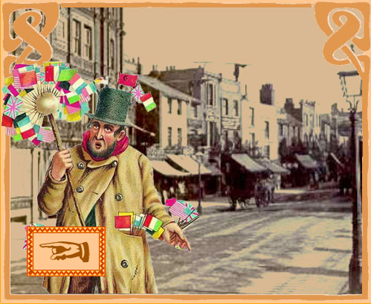  Figure 9 NPC - Informant
for you”)
- General game information (“If you’re in a hurry, never take a yacht – with no wind you are stuck!”)

Informant NPC has only one message defined, and gives this message to the player every time the player attempts to interact with this NPC. Informant type cannot be combined with any other types of NPCs.

QUEST PROVIDERs/RECEIVERs
Quest providers give players quests. This type of NPC has several messages:
- Quest message. (Description of the quest – the message displayed when the player talks to the NPC for the first time).
- Unfinished quest message (This message is given to a player which has received quest from this NPC but did not complete it yet). Can be something like “Hey, why are you still here? You know what you should do, right?”
- Failed quest message. Used if the player failed the given quest.
- Success message. Used when player talks to NPC after successfully completing its quest.
Important notice: quest provider does not, generally speaking, verify a completion of the quest – this is a responsibility of a quest receiver. However, it is possible that an NPC can combine quest provider and quest receiver types.
Quest receiver type is an endpoint for some of the quests. It is possible (but not yet finalized) that there can be a quest without an NPC quest receiver – something like “Go to Rome!”. Another interesting question (that is also not finalized yet): can a quest be something like “In Madrid, find Diego Alatriste, get a parcel from him and bring it back to me”? This kind of quest requires either a concept of chained quests, or two quest receivers…
The following is example of a regular quest with one quest provider and one quest receiver. The player encounters some professor of mathematics, who says “Here, take this small box, go to London and give it to Mr. S.H.”. In this case, the professor is a quest provider, and S.H is a quest receiver. When the player arrives to London and talks to Mr. S.H., the quest is marked as completed.
Quest receiver has the following messages:
- General response. Used if the player talks to this NPC before acquiring a quest for which this NPC is the receiver. (Something like “Nice weather, isn’t it?”)
- Quest completion response.
- Quest failure response. (For example, if the quest was a timed one, and the player didn’t make it in time.)
- Repeat success. (Player has been told already about the success, and talks to the NPC again)
- Repeat failure (Similar to repeat success, but the player failed quest).

KNOWLEDGE PROVIDER
Knowledge provider gives the player some information regarding Lost Cities. Knowledge provider NPC has also only one message – the piece of information it will give to a player. Knowledge provider acts very similar to informant, with one important difference: when activated by a player, it checks whether the player already had received its piece of information (AKA “Knowledge unit”), and, if no, records that now the player possesses this knowledge, and increases the percentage of Lost City knowledge the player has.
Knowledge provider type cannot be combined with any other types.
The following is the example of the “knowledge piece” that the knowledge provider might have:
“You are a member of that renown “Adventurers’ Club, aren’t you? I’ve heard the rumor that might be of use for you. Plato’s Critias dialogue was found by some estranged captain. Hmm.”
This fact is worth 10% of full knowledge about a lost city. And in the Lost Cities Screen one of the cities would get a “fact”: Plato’s lost Critias dialogue.
For the full list of “knowledge” available for different Lost Cities please refer to the Appendix A (page 39 ).

GATEKEEPER
This NPC is responsible for enabling a travel route to a lost city. The visual type of a gatekeeper is not assigned at random, but is selected based on a corresponding lost city (all gatekeepers are literary characters – Captain Nemo, Lord Glenarvan, Robur the Conqueror, etc.) Gatekeeper has the following messages: | 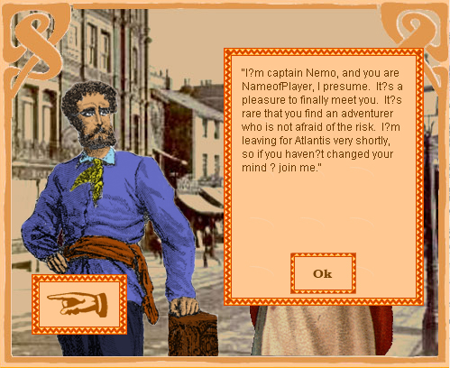  Figure 10 NPC – Captain Nemo

- A letter that is sent to the player when he has gathered 80% or over of “knowledge”.
- Enabling a route.
Example:
“Allow me to formally introduce myself – Lord Glenarvan. I’ve heard that you are quite an ambitious adventurer, and would like to find the Island of Dead Ships. Some people say it’s all just a myth, but I believe very strongly, that it exists. On one of my journeys I’ve seen it from afar. Let us waste no time, we’ll set sails today.”

- Message after the visit to the Lost City.

Right now for the prototype I have developed 5 characters of the type gatekeeper: Captain Nemo, professor Lidenbrock, Lord Glenarvan, Dr. Samuel Ferguson, Robur the Conqueror.
The message texts for the gatekeepers can be seen in Appendix B (page 44).

Lost Cities generation
Currently I have developed only 5 Lost Cities: Atlantis, Machu Picchu, The Sun City – (African jungles), Island of Dead Ships, Agharta. I’m working on creating a larger pool of Lost Cities. I’m hoping to have the pool of 15 – 20 cities. From the pool of Lost Cities 6 are randomly selected. Non-selected cities are not included in XML. The selected cities are marked in the database. All routes leading to non-selected cities are disabled and are not included in XML.
Then for each of the selected cities the following actions are performed:
1. Selecting route to city.
Each Lost City has several potential routes leading to it. Those routes are marked in the database. From all routes leading to the city one is randomly selected. All other routes leading to the city are marked as disabled. The city from which comes the selected route is called “gateway city”. The selected route is tagged as conditionally available. The availability is triggered by a “gatekeeper”.
From all routes going from the lost city one is selected that goes to the gateway city (so the player can enter the lost city only from the gateway city, and after visiting the lost city can only return back to the gateway city). All other routes going from this lost city are marked as disabled.
A “gatekeeper” NPC is placed in the gateway city. It is possible that a special quest should be generated, which player has to solve in order for a gatekeeper to open route to the city, and “gatekeeper” should in this case act as quest provider, quest receiver or both.
2. Knowledge distribution.
In order to make lost city visible on the map, the player needs to gather a certain amount of knowledge. Knowledge comes in “knowledge units”. Each knowledge unit has a percentage assigned. When the player receives a knowledge unit, the percentage is added to the score of knowledge about a city. When the score reaches certain amount (e.g. 80%), the lost city appears on the map. Each knowledge unit can be obtained only once.
The knowledge units are separated in two groups: large and small. Large units have higher percentage assigned, and are more difficult to obtain.
The system selects large units from the units table. Then the system selects N cities that are closest to the lost city (meaning the distance is minimal). N is defined as (number of large knowledge units)+ (extra cities). The extra cities are used to prevent knowledge units from being always assigned to the same cities. From the selected cities the system randomly selects a city per each large knowledge unit. A “knowledge provider” NPC is placed in the selected city and is assigned a knowledge unit.
Then the system selects small units from the units table. They go through a similar process as the large units, only they are placed further away from the Lost City than the large ones. Also there can be only one piece of knowledge in a given city.

Some mistakes
One of the major mistakes that I had so far was the fact that I was duplicating information across the classes, instead of referencing it. I had a class for the items’ values, but when I needed to create a new set of items, I was simply duplicating that original class’ fields into the new class. As a result, I got an immense number of classes with duplicated information. It is much better and easier to have one “values” class for the items, and then to make “visual” classes, where each “visual” class would have access to the information of the “values” class. “Visual” classes have the properties that affect the item’s visual look and positioning, however the core values the item gets from the “values” class.
Another major problem arose because I didn’t put in the time to create the “generic” pop-up window system. Instead, whenever I have a class, which needed a “pop-up”, that class was responsible for creating a “pop-up”. It turned out that the system had very many “pop-ups”, and programming all of them would have taken much less time, if I had created a “generic” system. I’m seriously considering reorganizing that part of the program, for in the long run, it will save time.
One of the usability problems appeared during a play test. In the original interface the player had to mouse over the current city and select the mode of transportation that he wanted to use. Then he had to mouse over the destination city to see the ticket that would show the time and price for that journey. That system was not working on many different levels. First of all it was not comfortable for the players to first have to choose the mode of transportation, and only then seeing where this mode will take them. They wanted to have ability to first see the city they can go to, and then think of the transportation mode. Secondly, when players were comparing prices between different tickets the game screen was quickly filling up with a multitude of pop-ups. It was practically impossible to see what was really going on. After the play test I saw how hard it was for the players to use the interface I’ve created, so I’ve made some drastic changes to that part of the interface. Now, there is a “Destination Screen” that appears as soon as player wants to leave the city. On that screen the player sees the cities that he can reach from his current place and those cities are organized based on modes. Next to the city’s name there is a price and the approximated time of travel.
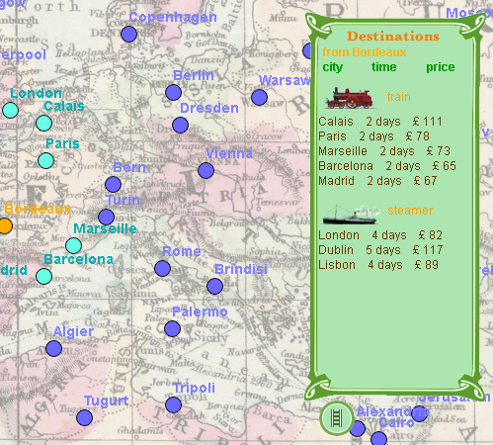
Figure 11 Destination Screen
When the player clicks on the city name in the “Destination Screen” the ticket will appear as the final confirmation of the purchase. By clicking on “buy ticket” the player begins his travel.
This system, so far, has proved to be much easier for the players to use. Also it is much easier to see now all the available routes. Also the “Destination Screen” has several buttons for filtering visual representation of the travel routes between the cities depending of the transportation mode.

DEVELOPMENT

Development Environment
The game is developed using Macromedia Director MX. This development platform was chosen because of the fact that Director provides powerful tools for working with multimedia, and at the same time is a solid programming platform.
Since Director programming language Lingo has some object-oriented features (though, unfortunately, a very rudimentary set), it was decided that the desktop part should be developed using OO methodology. This methodology gives me several important benefits, such as:
- improved code structure;
- higher flexibility and reusability;
- easier debugging.
To perform design, I’ve started with use case analysis. By creating several scenarios of user interacting with the system, I was able to identify candidates for classes (see App. C: Fig. 14 and Fig. 15). As the next stage, I’ve started designing classes, using class diagram and object interaction diagrams (see App C. Fig. 16) as handy tools to help me organize my thoughts.
The classes used in the desktop module can be separated in two groups: domain model classes, which represent certain objects in the game – player, cities, collectible items, transportation routes etc. – and visual representation classes, which are responsible for user interface. The later were implemented using Director’s behaviors, which are modular pieces of code attached to visual objects (sprites).
The question of data exchange with the server is very important. Since the game world is highly dynamic and is generated anew for each game, the client would need to receive from the server complete world description, and to receive regular updates later in the game. The client would also need to update the server with fresh information each time a player’s status changes significantly.
The data transfer happens over HTTP protocol, as it is easy to implement, and with highest probability will be available for most users. For the data format, I chose XML. Its structured nature makes it easy to retrieve objects information. The client will obtain data from the server by calling a server-side script, which will return XML file.

Programming Macromedia Director MX.

As a programming platform, Director has both strengths and weaknesses.

The main difficulties encountered during the development of Adventurers’ Club (AC) were:
- Absence of means to create composite graphical objects;
- Lack of support for dynamically generated sprites;

Composite objects

The ability to create composite graphical objects is very important for building UI. A good example of this kind of object is a dialog window – it has a frame, a background, a caption, “OK” button and the contents. All components of such window should behave in a consistent manner – they should move together if the window is moved, maintain correct Z-order, should be destroyed if the window is destroyed etc. In contrast with Macromedia Flash, which allows creation of such composite objects in the form of “Movie Clips”, Director provides no means for that. The only solution to this problem was:
- create an object (i.e. “parent script”), responsible for the behavior of the dialog;
- create a separate sprite for each part of the dialog and attach to them a behavior which will make them preserve their position relative to the dialog frame;
- maintain a list of the created sprites in the object and make the object responsible for destroying all dialog elements when the dialog window should be closed.

Dynamic sprites
The problem with dynamically generated sprites is a notorious problem of Director. The problem is very simple – there is no official way to create on the fly a sprite with dynamically specified contents. Unfortunately, the game such as “AC” requires a lot of dynamically generated sprites. In order to overcome this difficulty, I’ve employed the following method:
- Search for the next available channel by iterating over all channels searching for an empty one;
- Make a “puppet sprite” in this channel
- Duplicate a required member and assign created new member to the created sprite.

This method is not ideal – though I’ve created a convenience functions for creating and destroying sprites, some work was still to be done manually each time the new sprite was created. To make things worse, there are some rumors regarding memory leak in director which happens when the new members are created and destroyed programmatically at run time.

OOP specifics
As I’ve mentioned already, I’ve used some Object – oriented techniques while programming AC. Lingo provides a way to create objects by using so-called “parent scripts”. The parent scripts lack many useful OO features, but still are quite useful for organizing code and making it more structured, more modular, and, therefore, more reliable and easier to manage and maintain.

World generation tools
The game world is being generated on server. Generation of the game world consists of two phases: database population and XML file generation.
In the database population phase, the database is cleaned from the previous game data. Then the data for the new game is being generated and is stored in certain database tables. Not all the tables in the database are used to store new data – some of them are used to store fixed data (the data that is not changed from one game to another).
In the XML generation phase, the data is extracted from the database and is written out in XML form.
Both phases are implemented as PHP scripts. PHP is an extremely powerful scripting language, which can be used for dynamic generation of HTML web pages and XML files. As a database I use MySQL server. MySQL works very well with PHP.
Besides the scripts for world generation, I’ve also created some tools which helped me in designing the game world. For example, I have a tool which verifies the consistency of the transportation network (checks for unreachable parts, asymmetric routes etc.); another tool provides a GUI for changing state of some routes in the game; there are also some scripts which calculate intermediate data which later will be used by world generation scripts.

EVALUATION
The system will be evaluated based on the multitude of play-tests, which will be held throughout the development process. Play testers will need to belong to the target audience for the product. Only in evaluating the responses of play testers will I have more or less objective criticisms of the system’s victories and failures. It is important for this particular product to start play testing it as soon as possible, and I’ve already started by play-testing my paper prototype. In the beginning of the development process the play test should deal with the game’s interaction system more than with the actual game play. After each play test a questionnaire, focusing on the specific problems of that particular play test, will be distributed among the play testers.

CONCLUSION
The grown up gamers are a unique group of people that is yet to be studied more closely. There is a great opportunity of creating a specific product that answers grown up gamers’ needs more closely than what’s available on the market right now.
Even though the product of my thesis production is only a part of a greater idea, I feel that the core idea is strong enough to be further evaluated and explored. Building just a segment of the meta world of adventurers leaves a lot of room for growth and expansion.

Appendix A

Knowledge Distribution

Atlantis
Description of knowledge unit | Fact | %
I don’t like this technological boom we are experiencing. The steamers, the fast rails…  I’m sure you’ve heard of Atlantis. Did their superb technology help them? No, their whole metropolis was flooded in one day and one night. That’s nature for you, heh. | Some talks about Atlantis. | 10
You are a member of that renown “Adventurers’ Club, aren’t you? I’ve heard the rumor that might be of use for you. Plato’s Critias dialogue was found by some estranged captain. Hmm. | Some captain found Plato’s Critias. | 10
It is a fact that the location of the Atlantis is explicitly named in Plato’s lost Critias dialogue. | Location of Atlantis is in Critias. | 30
I know that Captain Nemo has the most intriguing book. But, he is so secretive. No matter how I tried, I could not learn what it is. And it’s a pity, because it would be a sensation, if I was to tell at the Academy what the book is. | Captain Nemo has a mysterious book. | 20
I’ve got a glimpse at the most extraordinary map. There is some great treasure just a little bit west of the Str. Of Gibraltar | Treasure - west of Gibraltar. | 20
I don’t trust the sea. It feeds us one minute, and the next one – it will kill us. I mean if it was able to swallow the entire continent, destroying one little boat is just a joke for it. I should just stay ashore. | Talks of the flooded continent. | 10

Machu Picchu
Description of knowledge unit | Fact | %
You call yourself an adventurer? Have you been up the Andes? The mountains have a lot to share with those who are persistent. | Check the Andes | 10
You’ve seen a lot during your adventures. Do you believe that things that are heavier than air can fly? A friend of mine said that he saw some machine, called “Albatross”, that is able to fly without the air-balloon. To be honest with you, I think that he was too much out on the sun. | Flying machine  “Albatross” | 20
There are no guides in Peru that are willing to go above 8000 feet in Andes. That place is cursed. Spaniards searched for centuries, and they, you know, had their means. But they were completely unsuccessful and couldn’t find the Incas’ Treasure. | Incas’ Treasure. Peru, Andes (above 8000 feet) | 20
I’ve just received a letter from my uncle in U.S. He is an associate professor at some institute in Philadelphia. Well, he goes on to suggest that some man, Robur, had given him a ride in the “Clipper of the Clouds” – the flying vehicle that is heavier than air!!! They have nothing to do at the institute than to make up stories. I will write back to him, that he should publish a novel. | Robur – possibly has a flying machine | 20
Some legends and myths have a lot of truth to them. So, if you want to find a treasure read up on the legends of Machu Picchu. | Machu Picchu (what does it mean again?) | 20
I’ve been up in Andes recently. It is so beautiful. Sometimes I just wish, I was a bird, and could fly over the mountains. I’m sure the birds find a lot of secrets up there. | Andes are beautiful (so should I go?) | 10

The Sun City – (African jungles)
Description of knowledge unit | Fact | %
My father told me that he saw what was left of Eden. He said, he and his fellow hunters, were moving through the jungles down south, and then they saw it – the most beautiful palace there is. He promised to take me there, but he was killed soon there after. | Eden in South Africa? | 10
The great adventurer Dr. Samuel Ferguson is about to launch a new expedition in Africa. I wish I could join him on his balloon “Victoria”. | Dr. Samuel Ferguson – famous balloonist | 30
I think it was the rebellious Egyptian nobility that migrated to Bophuthatswana and created The Sun City. People say Sun City is just a myth, but I’ve heard from some explorers that there might be truth to it. And that those volcanic craters should be examined further. | The Sun City | 20
I’ve known a doctor who dreamed of exploring Zanzibar on an air balloon. He is definitely the one worth talking to, if you are thinking of exploring Africa. Hmm.. Then again, I don’t remember his name. | Some balloonist likes to explore Africa | 15
I know of an amazing palace hidden in the jungles. But, there is no way on earth, that I will tell anybody about it. They will make it into some kind of tourist attrition, and I don’t care that much for tourists. | Hidden palace in jungles | 15
I don’t care for the adventurers. What do you want me to tell you? Where the treasure is? Well, there is no treasure. It was all eaten up by the volcano. | Treasure. Volcano. | 10

Island of Dead Ships

Description of knowledge unit | Fact | %
Adventurer? Hmm. Looking for exciting new places? How about exploring the Sargasso Sea? And it’s not the sea storms that you should be afraid of, but the cut-throats. Heh… | Pirates in Sargasso Sea!!! | 20
I heard a story from a drunken old sailor of the Island of Dead Ships. It is formed from a crust of flotsam and jetsam, weed, driftwood and wrecks. Maybe, though, it was all the rum, that he had that night, talking. | Island of Dead Ships. | 20
Do you need a daring captain and a good yacht? Search for Lord Glenarvan, he has traveled around the world in his Dunkan. | Lord Glenarvan (Dunkan) | 20
Some rich people cannot find what to do with their free time and money. They keep risking it all for something so silly as adventure. Why would anyone, in their right mind, ever try to save a man based on a note they found in a bottle? | Rich adventurer (too bad it’s not me) | 15
There are pirates nowadays, you know. They’ve created an entire city somewhere in the middle of the ocean. | Pirates’ city in the ocean. | 15
I met a guy. Who had a paid for several barrels of rum with a ton of old Spanish gold doubloons. He bragged that where he was from, nobody cared for doubloons, but it was the rum that was real gold. | Old doubloons | 15

Agharta

Description of knowledge unit | Fact | %
So you think the technology is pretty advanced nowadays? How naïve of you. You should read into the writings of wise men, who talk of the underground kingdom, which enshrines the whole wisdom of the ages in its libraries. | Underground kingdom | 20
My grandfather is sure that there is a mysterious underground kingdom – Agharta. It is situated somewhere beneath Asia and linked to the other continents of the world by a gigantic network of tunnels. Frankly, I think he is delirious. | Agharta (beneath Asia) | 30
I’ve heard of some twisty little passages that serve as an entrance to some secret kingdom. The means of entry, are said to be known only to certain high initiates, and the details are most carefully guarded because the kingdom itself is a vast storehouse of secret knowledge | Secret knowledge | 10
Yesterday I met the most strange man - Professor Lidenbrock. He insists that he has been to the center of the Earth. How ludicrous of him!!! | Professor Lidenbrock | 20
I’ve heard rumors of the new expedition being conducted by some renown professor. Can you imagine where to? To the center of the earth… | Underground expedition | 10
I know nothing of a Lost City in an area. And how could I, if the city is lost? | Some lost city in the area | 5
I’ve heard of a place, where it’s possible to learn the secrets of the relationship of soul to body. I’ve been searching all my life, and I can almost see my soul. But I’ve found no such place. | Some strange talk about body and soul | 5

Appendix B

Gatekeepers’ Messages:

Captain Nemo
I’m captain Nemo, and you are NameofPlayer, I presume. It’s a pleasure to finally meet you. It’s rare that you find an adventurer who is not afraid of the risk. I’m leaving for Atlantis very shortly, so if you haven’t changed your mind – join me.

Professor Lidenbrock
I’m professor Lidenbrock, I was told you were looking for me. You are lucky to catch me here, our expedition is all packed up and ready. But it’s too bad that you’ve missted my lecture on mineralogy. Well, maybe I will fill you in during our journey.

Lord Glenarvan
Allow me to formally introduce myself – Lord Glenarvan. I’ve heard that you are quite an ambitious adventurer, and would like to find the Island of Dead Ships. Some people say it’s all just a myth, but I believe very strongly, that it exists. On one of my journeys I’ve seen it from afar. Let us waste no time, we’ll set sails today.

Dr. Samuel Ferguson
Africa!!! I’ve missed it so much. There is still so much more to explore here, and this time my balloon “Victoria” is even better equipped then before. Oh, excuse my rudeness I forgot to introduce myself – Dr. Samuel Ferguson. I’m happy to find an adventurer who has as much interest in this continent as me.

Robur the Conqueror
You may call me Robur. I’m pleased to know of your convictions that a flying machine doesn’t have to be lighter than air. My “Albatross” will support your believes. Come aboard.

Appendix C: Game Design and Development

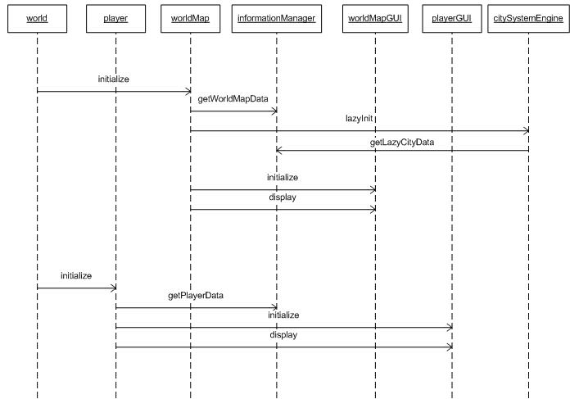
Figure 12. Objects Interaction Diagram - game start
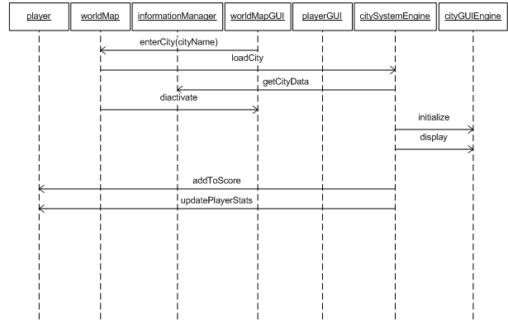
Figure 13. Objects Interaction Diagram - player enters the city
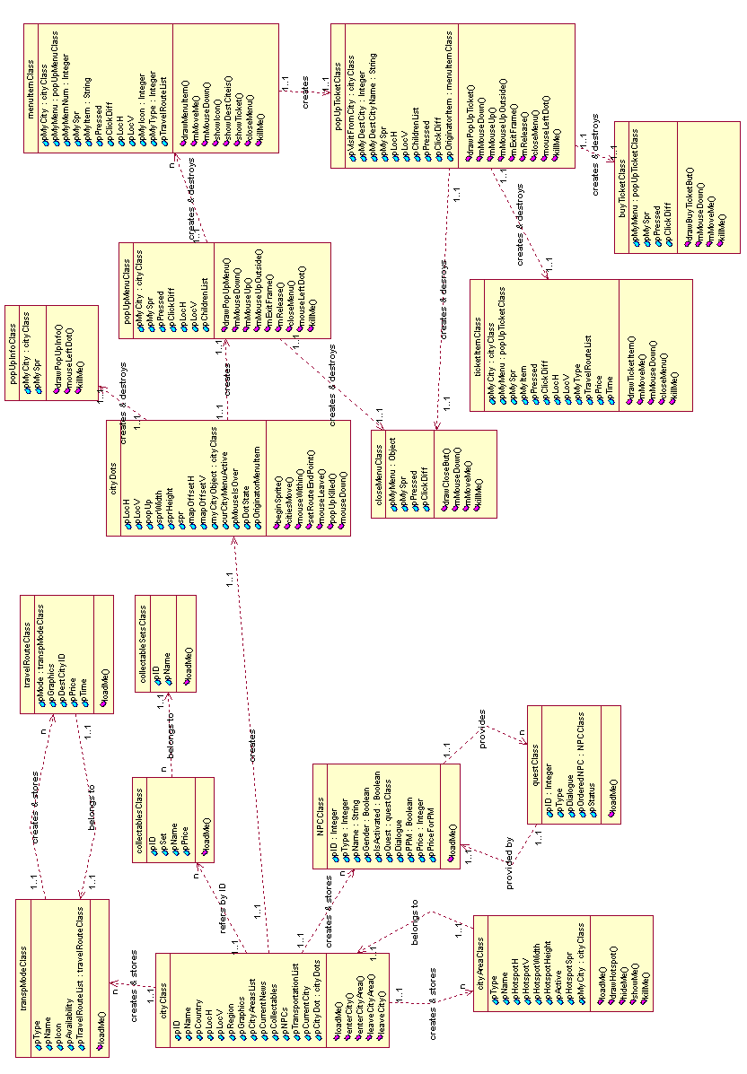
Figure 14. Class Diagram [this is the old iteration for the final I will provide a new one]

Figure 15. Database Design [this is the old iteration, for the final I will provide the new one]

Works Cited
Victorian Bazaar. "Eras of Time". 2000. Victorian Bazaar http://www.victorianbazaar.com/eras.html (Nov. 2004).

LUDOGRAPHY

Multi-platform games
A.I. Web Game
Puppet Master / Microsoft, 2001
A massive, web-based scavenger-hunt.
Developed for the movie A.I.
The game was played as if was not a game. Players were searching the web, calling on the phone, interacting with the actors from the game.
Lemonade Tycoon
Publisher: Airborne
Developer: JAMDAT Mobile Canada
Business simulation game
Players start with a small lemonade stand, and are aspiring to become multi-millioners. The same game is playable on both PC and Palm. So players are able to transfer data from their home computer, play on the go, and then at night transfer the data back to the desktop. Another aspect of the game is that the high scores of all the players in the “career mode” are displayed on the Lemonade Tycoon Stock Exchange:
http://www.lemonade-tycoon.com/
The game is an example of an attempt to make a multi-platform game, which will allow continuing playing the same game session on multiple platforms. “Lemonade Tycoon” provides the same gameplay on both desktop and handheld.
Majestic
Anim-X (published by Electronic Arts), 2001
Pushed the boundaries of a computer game with additional interaction.
“Majestic” attempts to achieve greater immersion by using real-world means of delivering information to the player, such as: e-mails, IMs, phone calls etc.
This game is another example of using several “platforms” (in this case – means of communication) to increase immersion.

Digital Games
Bejeweled
Popcap Games, 2001
“Bejeweled” is an extremely popular and addictive puzzle game, in which the player should assemble colored gems in groups of the same color.
Grand Theft Auto III
Rockstar North, 2001
“GTA 3” is an adult-oriented action game. All elements of the game were tailored to please adult gamers – the plot, revolving around criminal activities, graphical gore and blood, situations involving drugs and prostitution, sexual innuendoes and language.
Max Payne
3D Realms, 2001
Being an adult-themed FPS, the game is a good example of a “standard” way to make a game targeted on mature audience. The game is full of blood and gore, drugs and violence, all depicted in a very detailed and realistic manner.
There.com
“There.com” is a modern MUSH (Multi User Shared Hallucination). It is a place where people can hang out, chat and socialize with other participants.
Civilization (series)
MicroProse, 1991
Sid Meier
“Civilization” is one of the best turn based simulations/strategies. This game makes player to keep on playing by constantly providing new abilities and rewards. The game also serves as an example of making gameplay interesting by providing player with several axes of development and giving the player several different ways to win.
EverQuest
Verant Interactive, 1999
One of the most popular MMORPGs, the game also is an interesting example of an underground economy spawned by the game in real world. The players at one point were selling different game objects (items, avatars etc) on online auction sites for real money.
Oasis
Master Mind Video Games, 2004
Fast strategy gaming.
Oasis is an example of a strategy game with randomly generated “levels” and high replay value.
Sid Meier’s Pirates
Firaxis, 2004
This game was the most serious obstacle, which almost prevented me from completing my paper on time. It is an example of strategy game set in a historical setting, with an emergent gameplay and several axes of conflict.

Board/Card Games
Magic The Gathering
Publisher: Wizards of the Cost, 1983
Game Designer: Richard Garfield
This game started the genre of collectable cards gaming. Besides being a great game, for me it was especially interesting because the designers of “Magic” were among the first who realized the problem of grown-up gamers departing from the game, and attempted to solve it by introducing an online version of the game.
Ticket to Ride
Publisher: Days of Wonder Inc., 2004
Game Designer: Alan R. Moon
http://www.ticket2ridegame.com/
This game is set in 19th century and also is loosely based on Around The World in 80 days. This board game exemplifies the gameplay based on cross-country travel.

BIBLIOGRAPHY

GAME DESIGN & HISTORY
Crawford, Chris. Chris Crawford on Game Design.
Indianapolis, IN: New Riders Publishing, 2003
This book covers game design, game creation and game history from the point of view of the fields’ veteran. The book has a lot of insight on the issues of game design. It is full of personal anecdotes that make it ever more fun to read.
DeMaria, Rusel, and Johnny L. Wilson. High Score! The Illustrated History of Electronic
Games.
New York, N.Y.; London: McGraw-Hill/Osborne, 2002.
An illustrated retrospective on the evolution of the electronic gaming industry from the very first electronic game to what we have today. It has many interesting insights on the creation and development of great electronic games.
Fullerton, Tracy, Christopher Swain, and Steven Hoffman. Game Design Workshop
Designing, Prototyping and Playtesting Games.
San Francisco, Calif.: CMP, 2004.
This book features analysis of the formal and dramatic systems of game design. Authors focus in on important aspects of game design, as well as, prototyping and playtesting.
The paper prototype of the Adventurers’ Club was developed in accordance with this books explanation of the development of physical prototypes for the computer games.
Salen, Katie, and Eric Zimmerman. Rules of Play.
Cambridge, Mass.: MIT Press, 2004.
“Written for game scholars, game developers, and interactive designers, Rules of Play is a textbook, reference book, and conceptual guide. It is the first comprehensive attempt to establish a solid theoretical framework for the emerging discipline of game design” (Rules of Play back cover).
This book is a great resource for a game designer. The theoretical framework, described in Rules of Play, had a major influence on the process of creating rule-set for the Adventurers’ Club. “Emergent behavior”, “meaningful play” are just a few of the terms from this book that were paid high attention to during the game design process.

GAMING
Greenspan, Robyn. "Girl Gamers Grow Up". www.clickz.com. 12 Feb. 2004.
<http://www.clickz.com/stats/big_picture/demographics/article.php/3312301> (Sept. 2004).
Talks about the fact that gaming is more addictive among adults then teenagers; as well, as the fact that women over 40 play online games more than any other market segments.
The New Paper. "As Gamers Get Older, Games Get Naughtier".
Singapore Press Holdings Ltd. 02 Nov. 2004. <http://newpaper.asia1.com.sg/top/story/0,4136,76440,00.html> (Nov. 2004).
A discussion of why gamers (and especially “grown-up” gamers) are getting ready for the “adult” content in games.
Perry, Douglass C. "A Retrospective on Grand Theft Auto". ps2.ign.com. 10 Sept. 2002.
<http://ps2.ign.com/articles/370/370539p1.html?fromint=1> (Sept. 2004).
An article describing the Grand Theft Auto phenomenon.
Ratan, Suneel. "What Gamers Want: Year in Review". www.wired.com. 23 Dec. 2003. <http://www.wired.com/news/games/0,2101,61682-2,00.html?tw=wn_story_page_next1> (Aug. 2004).
An article with the focus on the growth of the mobile gaming.
Tapwave Zodiac Advertisement.
Magazine Ad. PC Magazine, 2004. 42.
Tapwave Zodiac is a Palm-based gaming platform, and it is positioning itself as “PDA for the Grown-Up Gamers”.

VICTORIAN ERA: HISTORY & DESIGN
Freeman, Larry, and American Life Foundation. Victorian Posters.
Watkins Glen, N.Y.: Distributed by Century House, 1969.
A collection of the Victorian posters. Not only a great visual resource but also a historical account of what was being advertised during the Victorian times.
Landow, George P. "What Was Victorian Taste, Really?" 1999. Victorian Web <http://www.victorianweb.org/art/design/taste1.html> (Nov. 2004).
A discussion of what was popular during the Victorian period.
Margaret Woodbury Strong, Museum, and Gallery University of Rochester. Memorial Art. A Scene of Adornment: Decoration in the Victorian Home from the Collections of the Margaret Woodbury Strong Museum: Exhibited at Memorial Art Gallery of the University of Rochester, March 7-April 13, 1975. Ed. Anonymous. Rochester, 1975.
A collection of decorative objects that were highly popular during the Victorian period.
Marshall, Peter. "John Thomson: China and London". about.com <http://photography.about.com/cs/documentary/a/a041504.htm> (Dec. 2004).
An overview of life and work of a great photographer of the late 1800’s John Thomson.
Menten, Theodore. Art Nouveau Frames and Borders Cd-Rom and Book: 199 Different Copyright-Free Designs.
Dover Electronic Clip Art. Ed. Anonymous. Mineola, N.Y.: Dover Publications, 1997.
Several of borders available from this collection were used in the graphic design of the Adventurers’ Club.
MyFonts.com, Inc. "Myfonts: Online Source for Finding, Trying, and Buying Fonts". 2004.
<http://www.myfonts.com/> (November 2004).
A great resource in finding the appropriate fonts.
Phinney, Thomas W. "A Brief History of Type". 2002. <http://www.redsun.com/type/abriefhistoryoftype/> (Oct. 2004).
An overview of the history of type.
Porret, Henri Desire, and Carol Belanger Grafton. Victorian Spot Illustrations, Alphabets, and Ornaments from Porret's Type Catalog.
Dover Pictorial Archive Series. New York: Dover, 1982.
A variety of Victorian spot illustrations and design elements.
Racinet, A., Mary Alexander, and Peggy Vance. Illustrated History of European Costume: Period Styles and Accessories.
London: Collins & Brown, 2000.
Illustrations of historical costumes.
Stearns, Peter N., and William L. Langer. The Encyclopedia of World History: Ancient, Medieval, and Modern, Chronologically Arranged.
6th ed. Boston: Houghton Mifflin, 2001.
Overview of world history.
timelines.info. "Timelines.Info". Bristol, UK. Conceive Ltd http://www.timelines.info/ (Dec. 2004).
A very quick way to get a sense of what was going on in a given year in a given country.
Victorian Bazaar. "Eras of Time". 2000. Victorian Bazaar
<http://www.victorianbazaar.com/eras.html> (Nov. 2004).
A historical and artistic overview of the Victorian Era

PERSONAL INTERVIEWS
Fortugno, Nick. Personal Conversation. Game designer. October 2004.
Nick is an established game designer and educator. He also agreed to be my thesis advisor.
We had a discussion on the importance of having the conflict in any game system, and on the need of having several “axis” of resolving that conflict.
Mersov, Tim. Personal Conversation. Gamer. December 2004.
Tim is a hard core gamer. He has been playing MMORPG games for the past 6 years. The discussion that we had focused in on the game of EverQuest and on the market of EverQuests’ game objects.

Published by Wizards of the Coast, 1993
Published by Rockstar Games, 2001
Published by Rockstar Games, 2001
MMORPG – Massive(ly) multiplayer online role-playing games
PDA – personal digital assistant
TETRIS – created by Alexey Pajitnov 1984
Published by Days of Wonder 2004
Beta Version, by Mind Control Video Games 2004
NPC – Non Player Character
Object Oriented
PHP – www.php.net
XML – extensible markup language
MySQL - open source database technology (www.mysql.org)

